Grade 7 Accelerated · Unit 3 · Lessons 6–7  Evaluating and Equivalent Expressions  Question Bank 3.06 ANSWER KEY | Name  Date  Period

Show your work. Circle your final answer.
For questions 1 through 5, apply the laws of exponents to evaluate. Show your steps.
1. 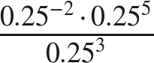
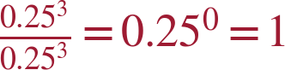

2. 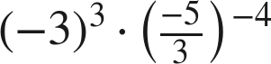
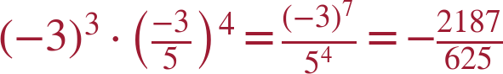

3. 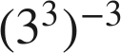
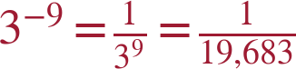

4. 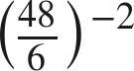
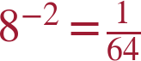 (or 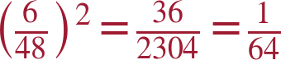)

5. 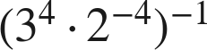
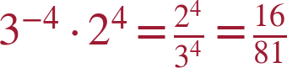

Evaluate each expression in questions 6 through 10. Then name the laws you used.
6. 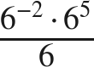
36 — product of powers, quotient of powers

7. 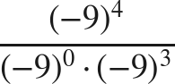
−9 — zero exponent, quotient of powers
(−9)¹.

8. 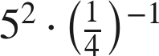
25 · 4 = 100 — negative exponent

9. 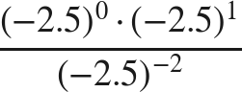
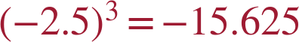 — zero exponent, quotient of powers

10. 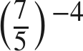
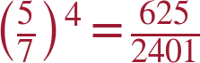 — negative exponent, power of a quotient

Common bases.
11. Write each expression as a single power with the base given.
a. 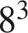 with base 2

b. 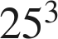 with base 5

c. 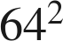 with base 8

d.  with base 2

4² = 2⁴.

12. Marquise says 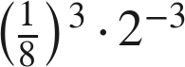 and 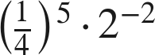 are equivalent because both can be written as 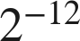.
a. Write the first expression as a single power of 2. Show your work.

(1/8)³ = (2⁻³)³ = 2⁻⁹.
b. Write the second expression as a single power of 2. Show your work.

(1/4)⁵ = (2⁻²)⁵ = 2⁻¹⁰.
c. Is Marquise correct?
Yes — both are .

13. Which expression is equivalent to 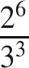 ?
○ A. 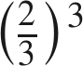
○ B. 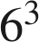
○ C. 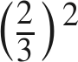
● D. 
D
3⁻³ · 2⁶ moves the 3³ down; the value is 64/27.

14. Find the value of that makes each statement true.
a. 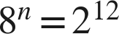
n = 4
(2³)^{n} = 2^{3n}.
b. 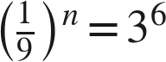
n = −3
(3⁻²)^{n} = 3^{-2n} = 3⁶.

